CELL THEORY

Cell theory describes the main ideas about the importance of cells and their role in living things.

The combined cell theory included the following three principles.

• All organisms are composed of one or more cells
• Cells are the basic unit of life and structure
• New cells are created from existing cells.

Any living thing that has more than one cell is referred to as multicellular.

There are many living things, such as bacteria, that consist of only one cell. These are called single celled or unicellular organisms.

Micro-organisms are often referred to as microbes.

Living things can be divided into five kingdoms — Animalia (animals), Plantae (plants), Fungi (for example, mushrooms), Protoctista (also called Protista) and Prokaryotae (also called Monera).

Prokaryotes are the bacteria that were the first type of organism to appear on Earth.
• The key difference between prokaryotes and all other kingdoms is that members of this group do not contain a nucleus or other membrane‐bound organelles.

Eukaryotic organisms contain a nucleus.
• Members of the kingdoms Animalia, Plantae, Fungi and Protoctista are
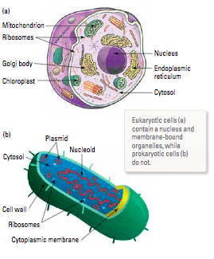
made up of cells containing a nucleus and other membrane‐bound organelles.

LIMITATIONS TO CELL SIZE

The cell’s skin or membrane is particularly important because it provides a barrier between the inside of the cell and the external environment.

The materials required for cell functioning (food, O₂, H₂O) and the waste products produced by these processes are all transported across the cell membrane.

It is essential that the cell membrane provides a large surface area for the transport
of so many molecules into and out of the cell.

The total space inside the cell is referred to as the cell’s volume. As a cell increases in size, its volume increases. A comparison of these two values as a fraction - the surface area to volume ratio - reveals exactly why cells are limited in size.

Example

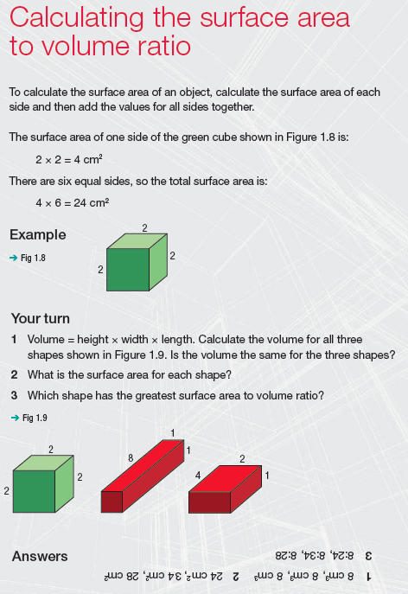

If the ratio is high, then the cell is able to move substances across the membrane
quickly.

i.e. By being small, a cell has a large surface area with a small volume.

